**Final Syllabus – Maths 2205 (Statistics and Probability)**

* **Bayes Theorem/Conditional Probability**
* **Discrete random variable**
* **Probability Distribution**
* **Binomial distribution**
* **Poisson distribution**
* **Normal Distribution**
* **Continuous Random variable**
* **Hypothesis Test and Estimation**

**Bayes Theorem/Conditional Probability**

**1**.

1% of a population have a certain disease and the remaining 99% are free from this disease. A test is used to detect this disease. This test is positive in 95% of the people with the disease and is also (falsely) positive in 2% of the people free from the disease. If a person, selected at random from this population, has tested positive, what is the probability that she/he has the disease?

**2.**

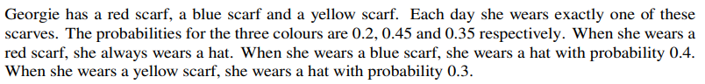





**Discrete Random Variable**

3.



**4.**





**5.**

The probability distribution for the random variable X is given by the following table. [ 2+4+2 = 8]

|  |  |  |  |  |  |
| --- | --- | --- | --- | --- | --- |
| x | 0 | 1 | 2 | 3 | 4 |
| P(X = x) | 0.03 | 2a | 0.32 | a | 0.05 |

1. Find the value of a
2. Calculate E(x) and Var(x)
3. Hence fine E(4x-1) and Var (4x-1)

**Binomial Distribution**

**6**.

In a certain town 60% of the homes have an internet connection. [ 2+3+3 = 8]

1. In a random sample of 20 homes in this town, find the probability that
2. Exactly 12 have internet connection
3. Exactly 5 do not have internet connection
4. Use a suitable approximation to find the probability that more than 360 homes of a random sample in this town have internet connection.

**Poisson Distribution**

**7.**







**8.**

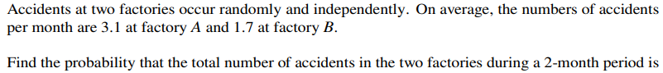



**Normal Distribution**

**9**.

**10**.

**11**.

**Continuous random Variable**

**12.**







**13.**



**14.**

**15.**



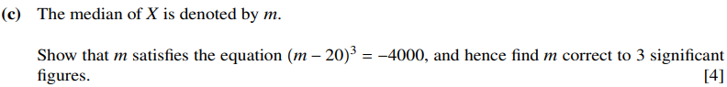

**Hypothesis**

**16.**

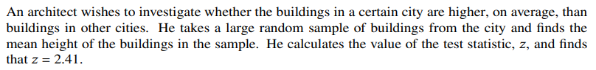





**17.**





**18.**





**Estimation**

**19.**

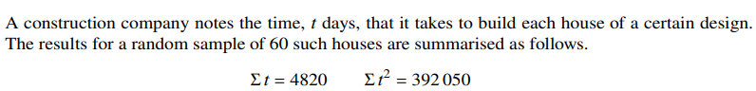



**20.**

